
City of Moreno Valley
Community Development Department
Planning Division
City Hall Council Chamber
14177 Frederick Street
Moreno Valley, CA 92553

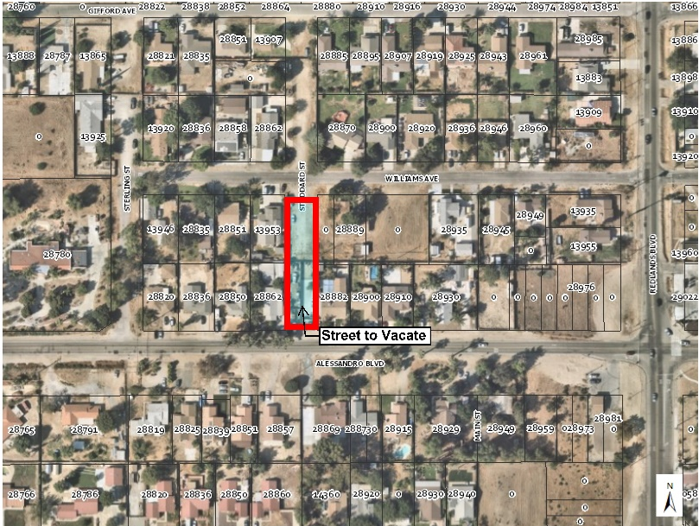
NOTICE OF PUBLIC HEARING
Notice of Public Hearing before the Planning Commission of the City of Moreno Valley for the following item(s):
Postal Ave
MEETING INFORMATION: February 27, 2020, 7:00 P.M.
Moreno Valley Council Chamber, 14177 Frederick Street
PROJECT LOCATION: Stoddard Street between Williams Avenue and Alessandro Boulevard contingent to assessor parcel numbers 478-175-004, 478-175-011, 478-176-001 and 478-176-008, in District 3.
CASE NUMBER(s): LGL19-0053
CASE ENGINEER: Guy Pegan, P.E., Senior Engineer
(951) 413-3115 or guyp@moval.org
<APN>
<Property Owner>
<Street Address>
<City, State, Zip>

NOTICE OF PUBLIC HEARING

PROPOSAL:

Street vacation, at the request of an adjacent property owner, to vacate that portion Stoddard Street between Williams Avenue and Alessandro Boulevard.

ENVIRONMENTAL DETERMINATION:
As designed and designated, the proposed vacation is exempt from the provisions of the California Environmental Quality Act (CEQA) under CEQA Guidelines Section 15601(b)(3) for Existing Facilities.

HEARING:
Any person interested in the proposal may speak at the hearing or provide written testimony at or prior to the hearing. The application file and environmental documents may be inspected at the Community Development Department at 14177 Frederick Street, Moreno Valley, California during normal business hours (7:30 a.m. to 5:30 p.m., Monday through Thursday and 7:30 a.m. to 4:30 p.m. on Fridays), or you may telephone (951) 413-3206 for further information.

The Planning Commission, at the Hearing or during deliberations, could also consider and approve changes to the vacation or the environmental determination. If you challenge this vacation, including any modifications considered for the vacation, in court, you may be limited to raising only those items you or someone else raised at the Public Hearing described in this notice, or in written correspondence delivered to the Planning Commission on or before the public hearing.

